Title: Approaches to managing organisational change

**Intro**

Change has become an inevitable need in this thriving world due to internal and external circumstances affecting businesses. Every day, new initiatives and projects are launched to improve performance, increase profits, and enhance your competitive advantage.

Why do some changes succeed and others fail? The answer: The people side

Organizations don't change, individuals do. Effective change management requires an understanding for and appreciation of how one person makes a change successfully. Decades of research shows various actions can be taken to inspire people in their individual transitions, which enable them to move from their own current states to their own future states.

Testimonial of Daniel Grant, managing director of Change ACT Ltd

*After attending a PROSCI® Change management course in South Africa last year, I came out of this experimental workshop* ***transformed****. I knew I had to bring this solution to the Mauritian market. Change ACT has collaborated with the South African firm “and Change”, PROSCI® primary affiliate, and has started this change journey in February. The success with people we have trained has been tremendous so far and we look forward for more successful stories.*

The PROSCI® Methodology

PROSCI® is the leading Change Management research organization in the world.

The methodology covers two fundamental models: To deal with change at a personal level, using ADKAR® model and the other to deal with change at an organizational level through the Three Phase Model with defined steps and tools for every phase:

Preparing for Change Managing Change Reinforcing Change

Managing change across multiple cultures – Tom Marsicano, founder and Director of and Change, and a Master Certified PROSCI® Instructor

Change is changing. Organisations operate in a society that has its own value system.

Before, the focus was mainly on telling people of the change with little interest on how they felt about it. As a result, managing culture changes only occurred in around 10% of projects. Nowadays, about 80% of course attendees are either solely focused on “changing the culture” or pay considerable attention to values, the way things are done, attitudes, and/or the culture.

Should you wish to embark on a new organizational change journey, Change ACT Ltd would be delighted to assist you.

Follow us on [LinkedIn Icon]

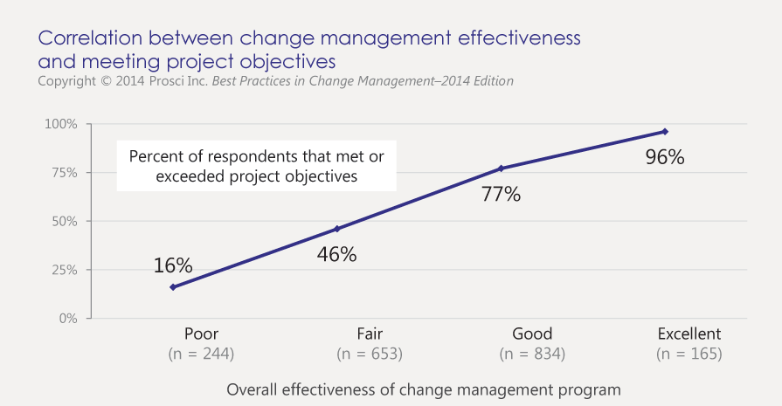

*Source: Prosci.com*